Evaluation function:

Piece subtraction

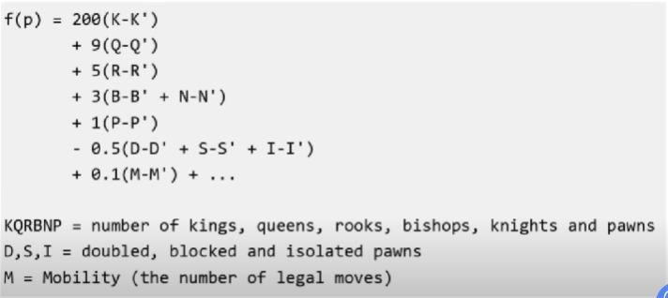

value of pieces, board position, control of centre, vulnerability of king to check, vulnerability of queen